**LAPORAN PRAKTIKUM 1**

**APLIKASI MOBILE**



**DISUSUN OLEH:**

**Najwa Azka Thalita Mehdi**

**2211533012**

**Dosen Pengampu:**

**Nurfiah, S.St, M.Kom**

**DEPARTEMEN INFORMATIKA**

**FAKULTAS TEKNOLOGI INFORMASI**

**UNIVERSITAS ANDALAS**

**PADANG**

**2024**

1. **LoginActivity**

Digunakan untuk masuk ke aplikasi laundry. Akan melakukan login terlebih dahulu.

**Java:**

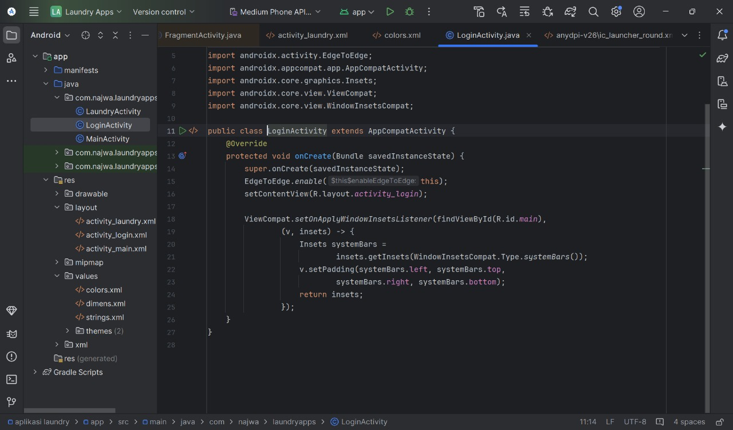

**XML:**

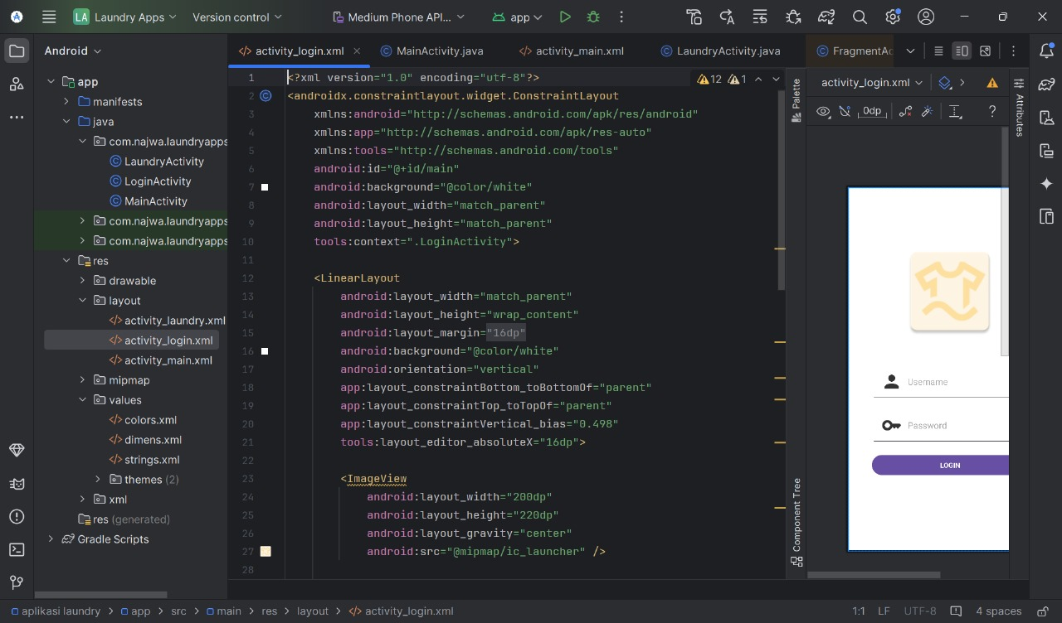

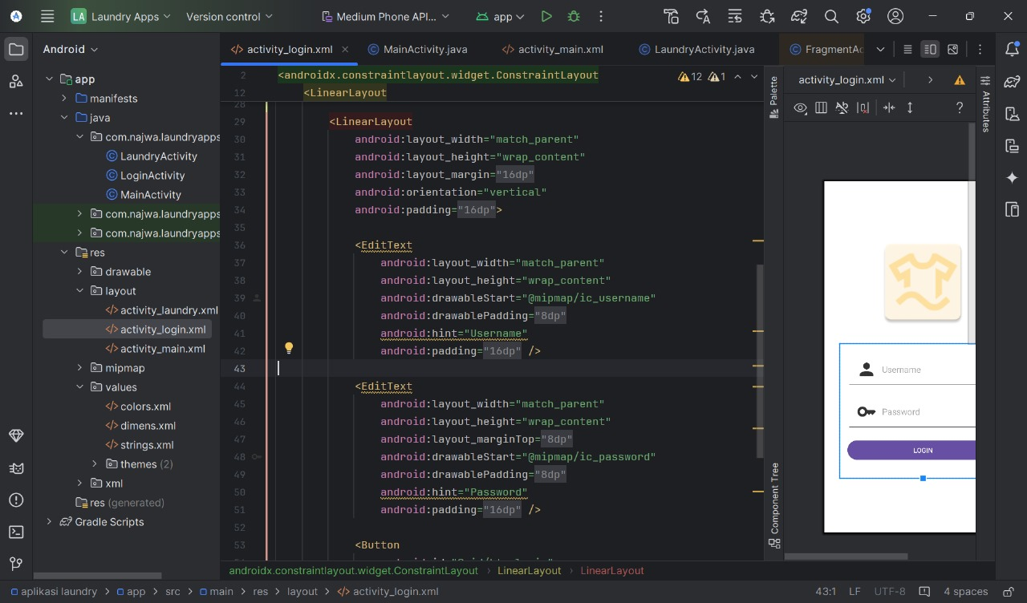

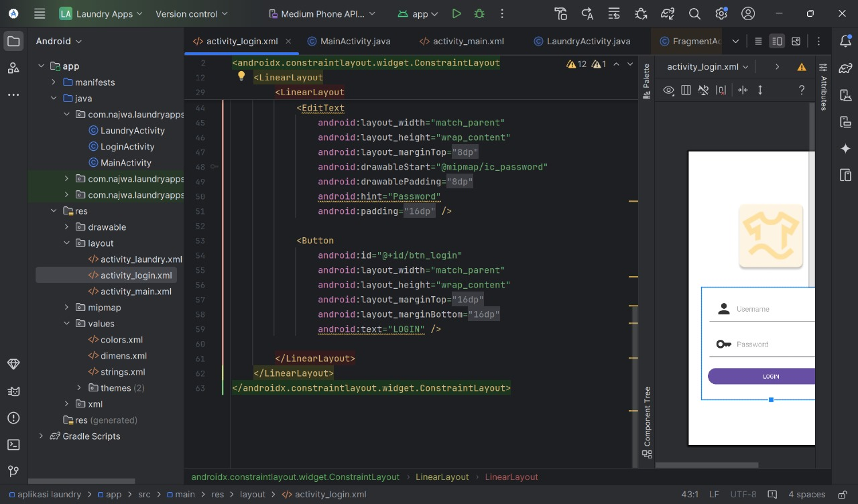

**Tampilan:**

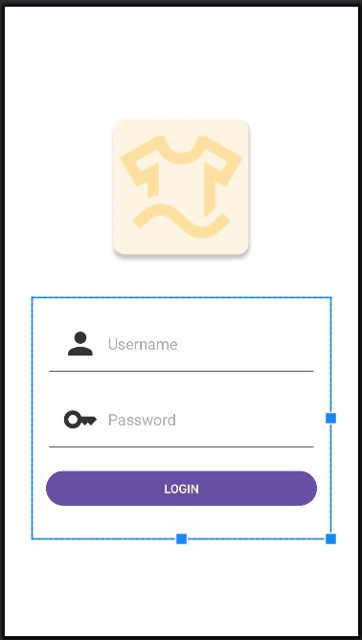

1. **MainActivity**

Digunakan saat pengguna telah melakukan login dan akan diarahkan menuju diarahkan ke halaman utama untuk memilih jasa yang di inginkan.

**Java:**

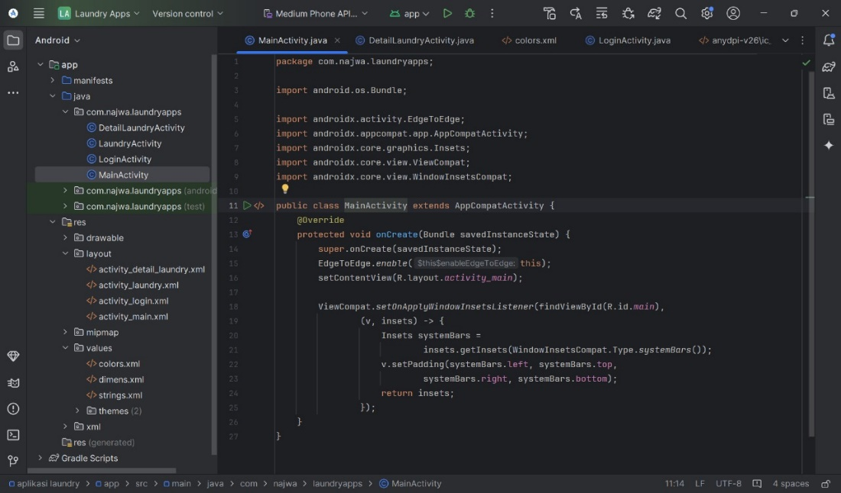

**XML:**

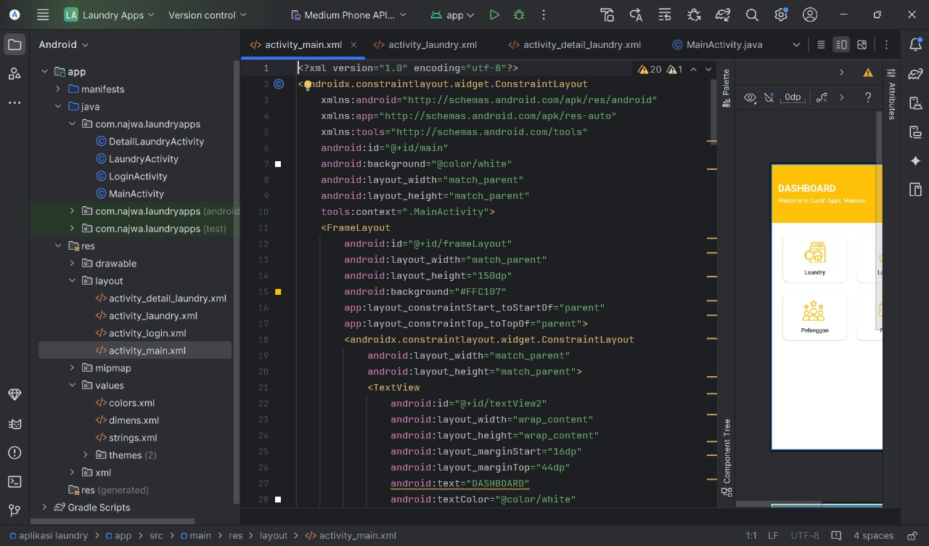

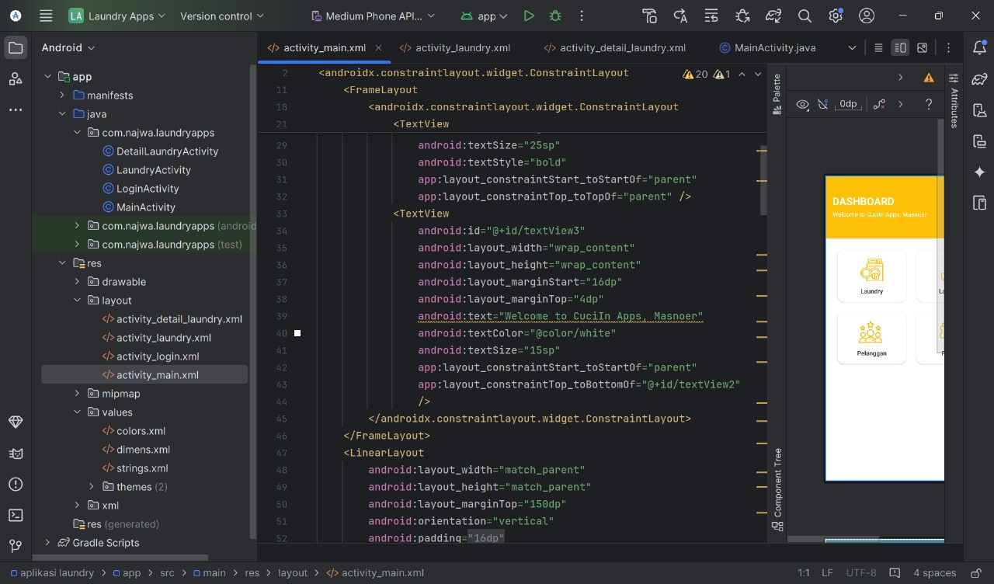

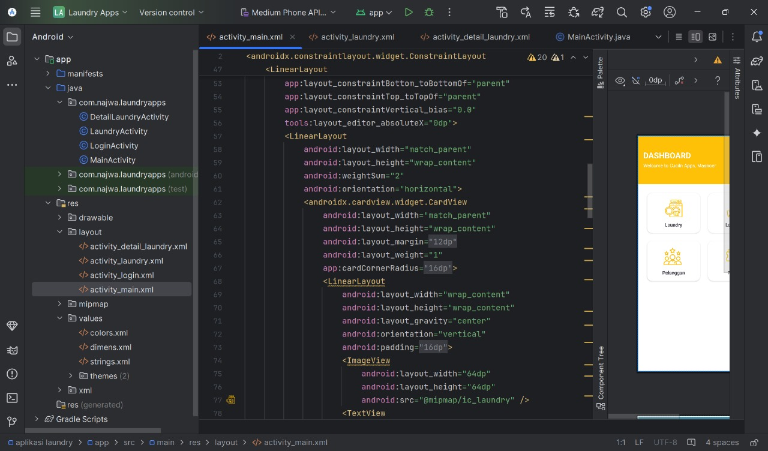

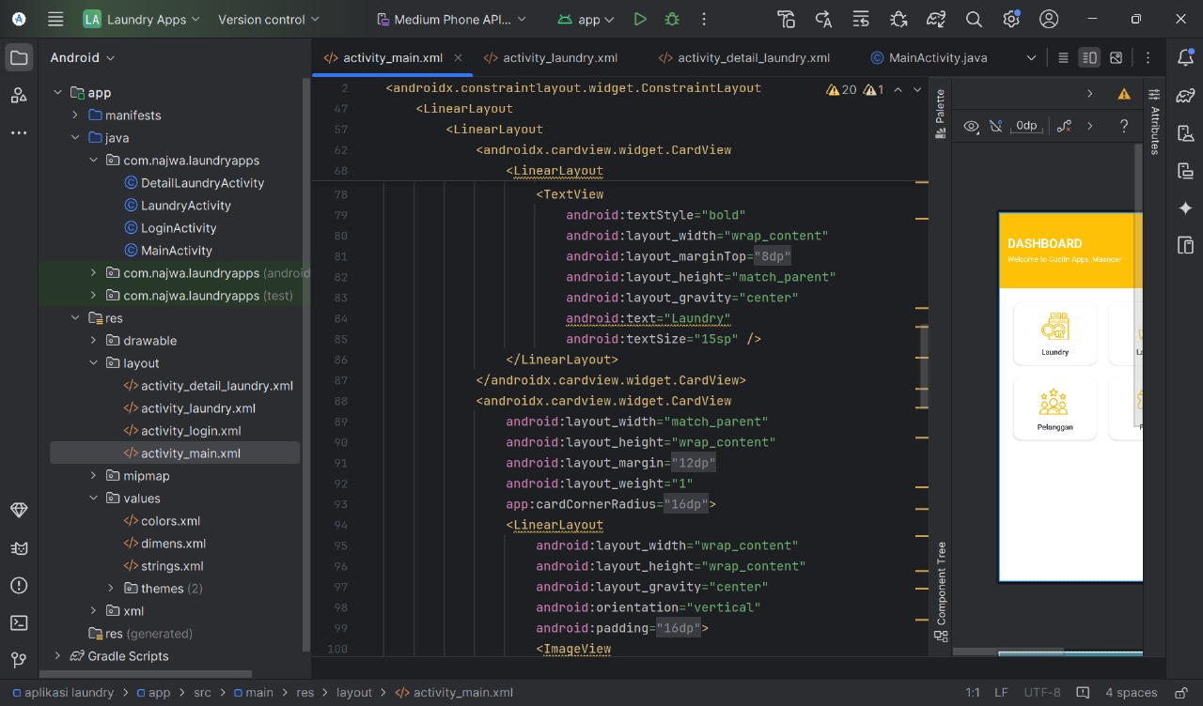

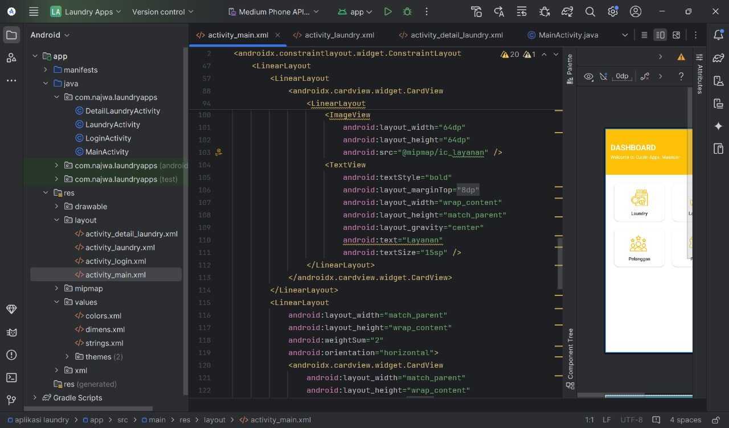

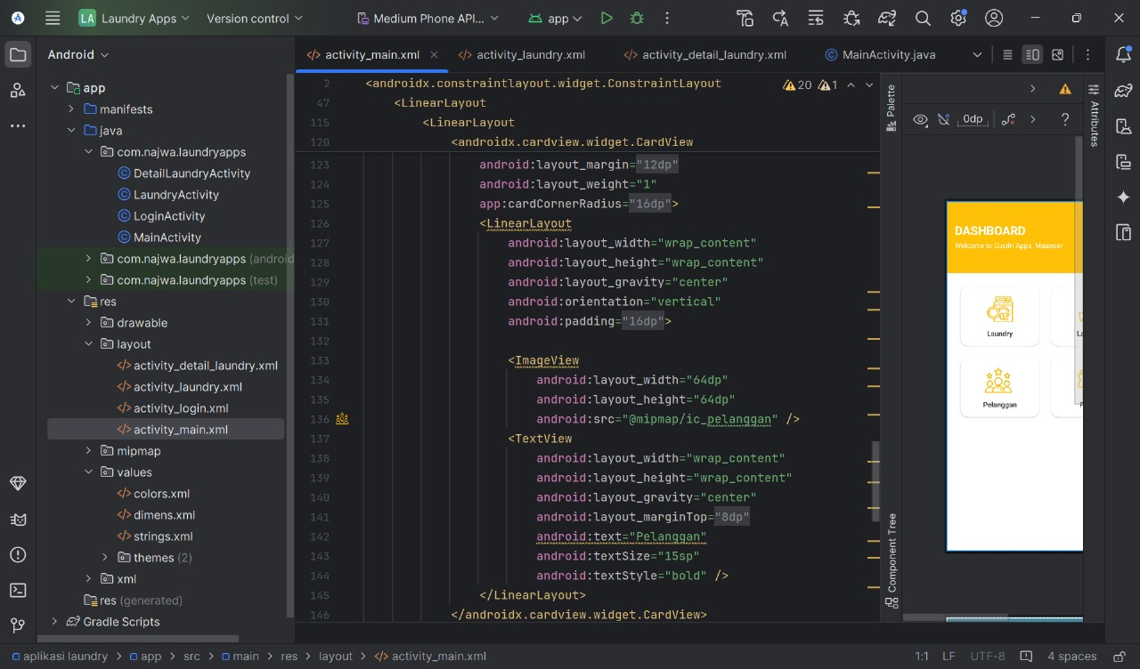

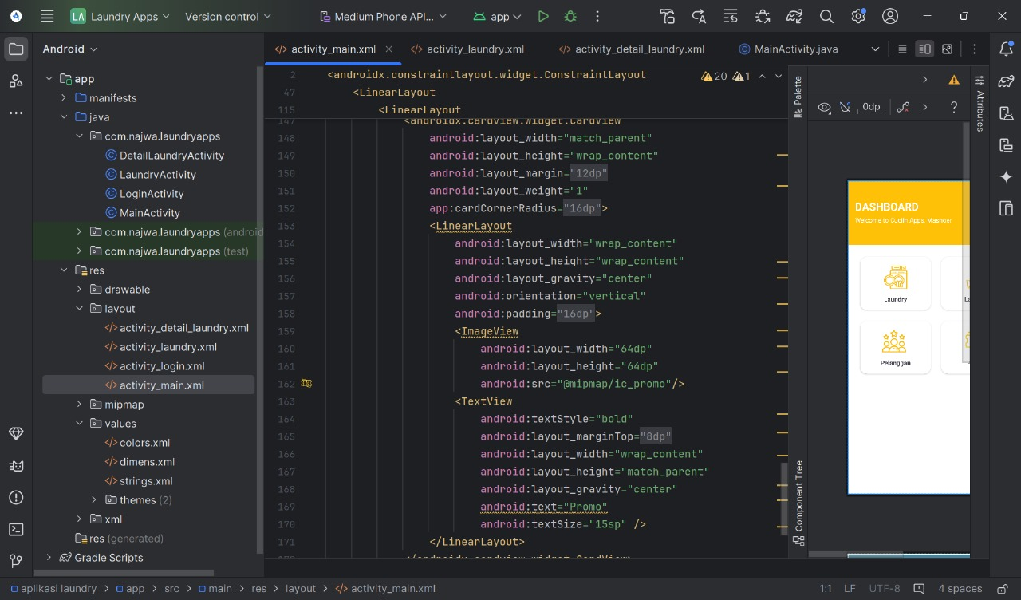

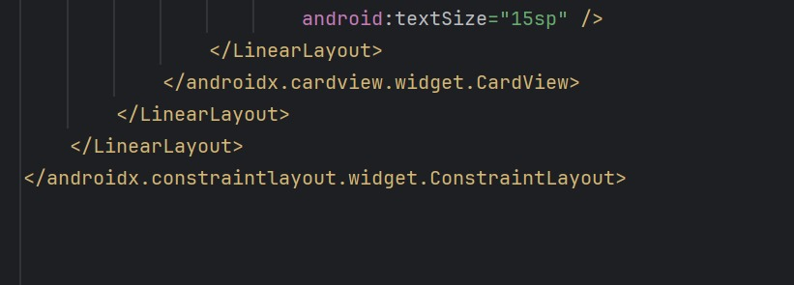

**Tampilan:**

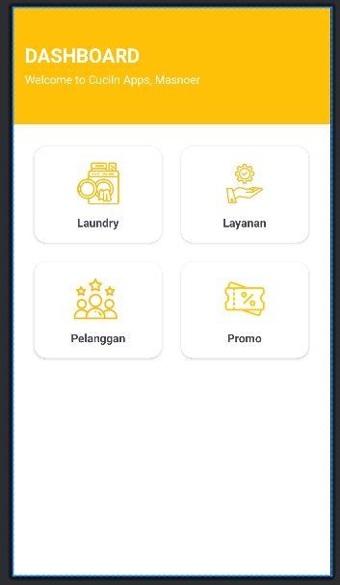

1. **LaundryActivity**

Activity digunakan untuk menampilkan Riwayat transaksi dari user secara singkat.

**Java:**

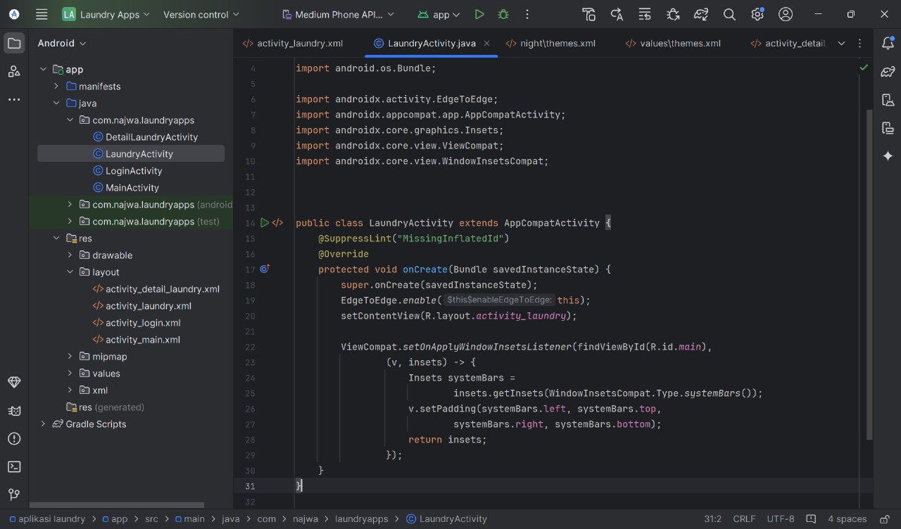

**XML:**

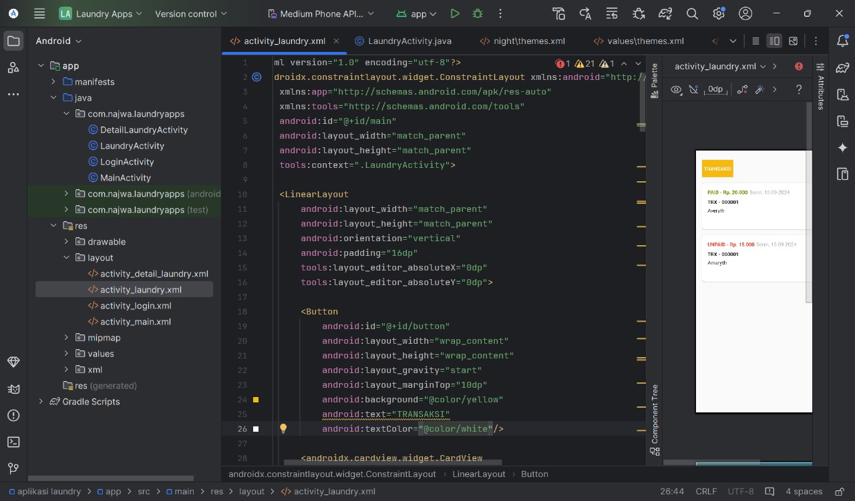

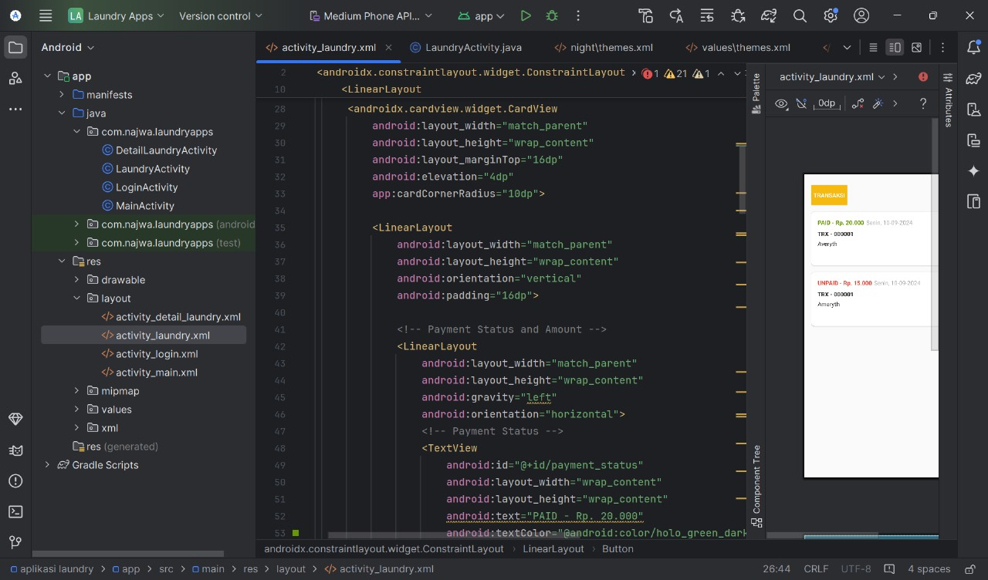

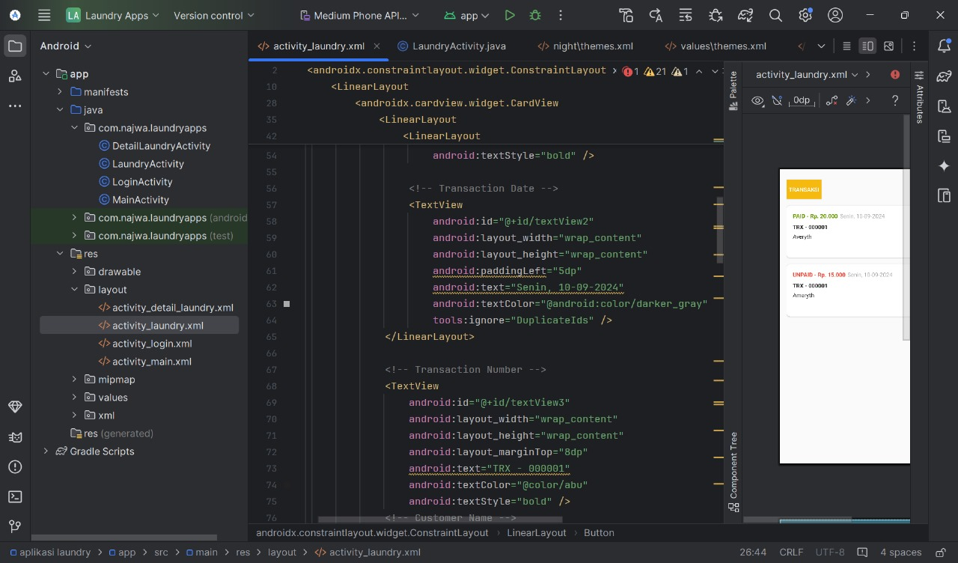

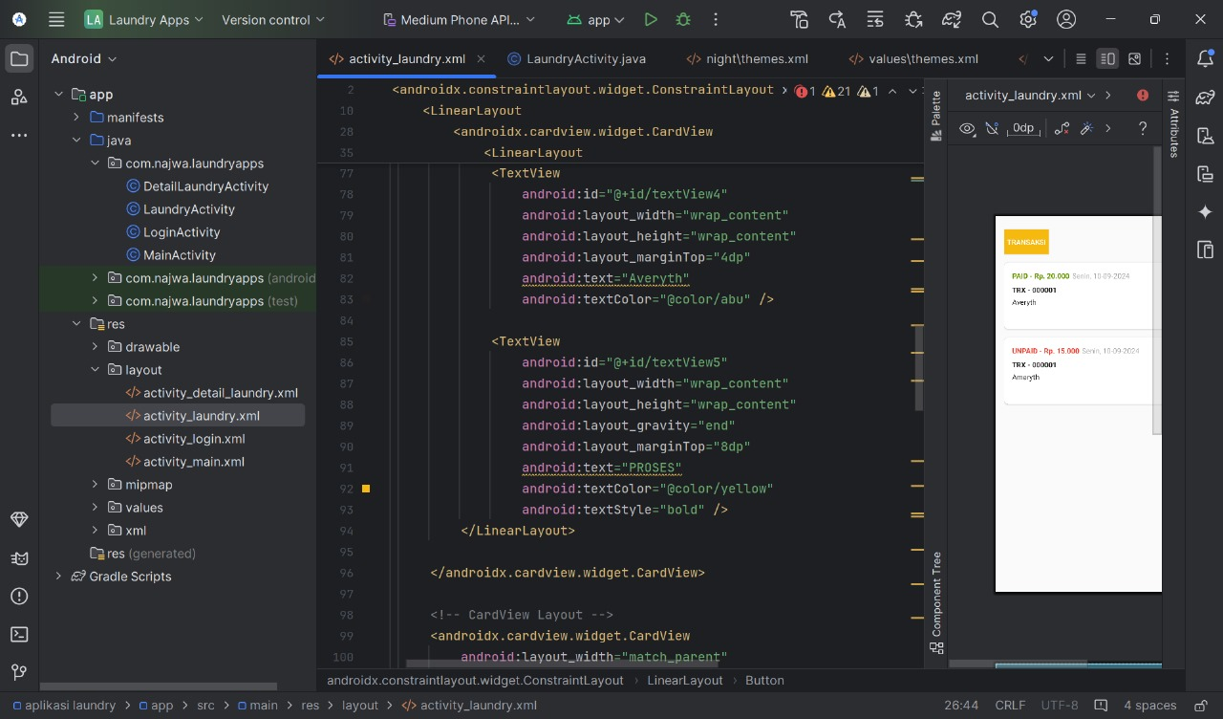

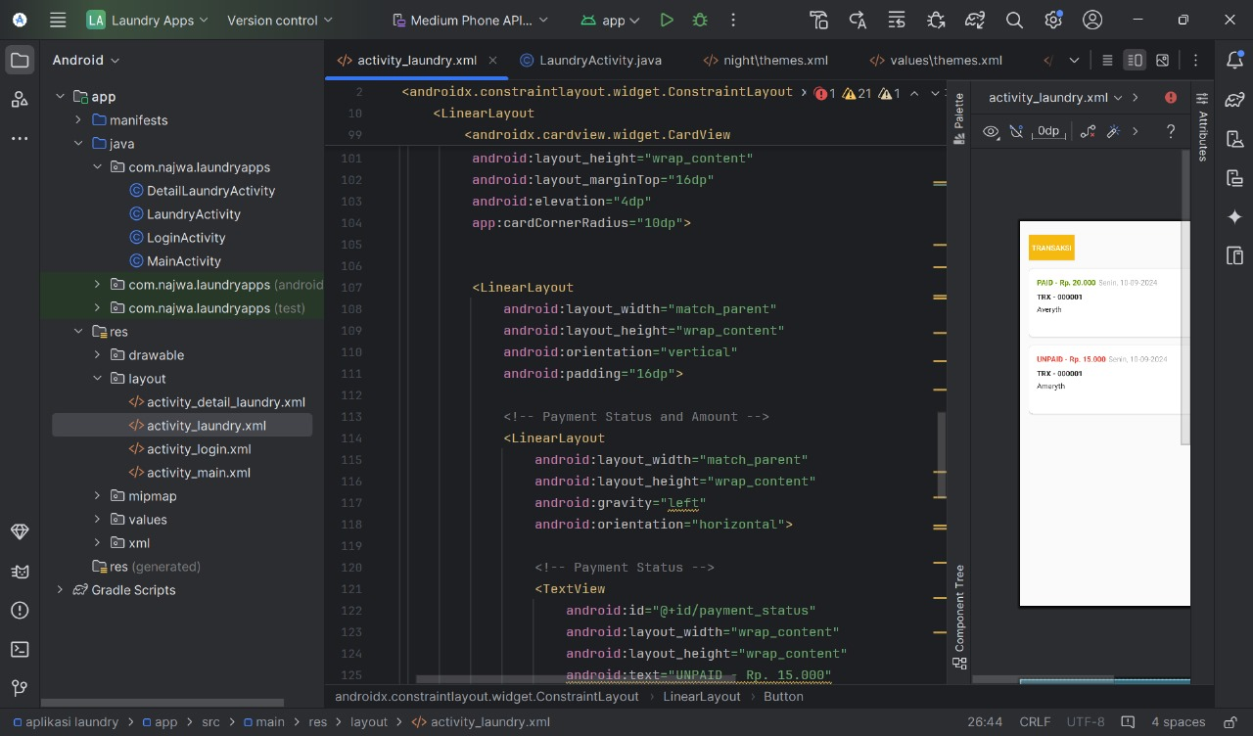

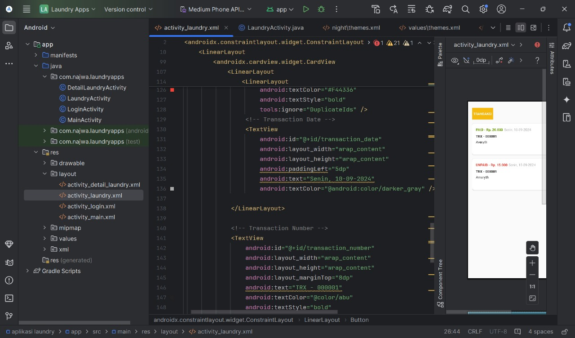

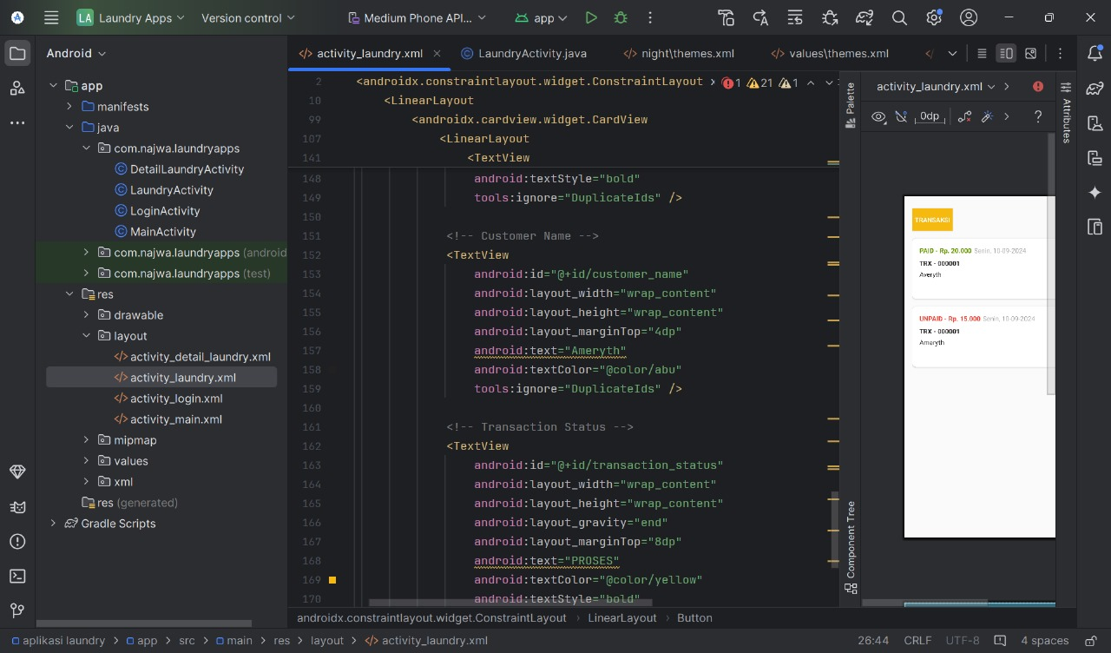

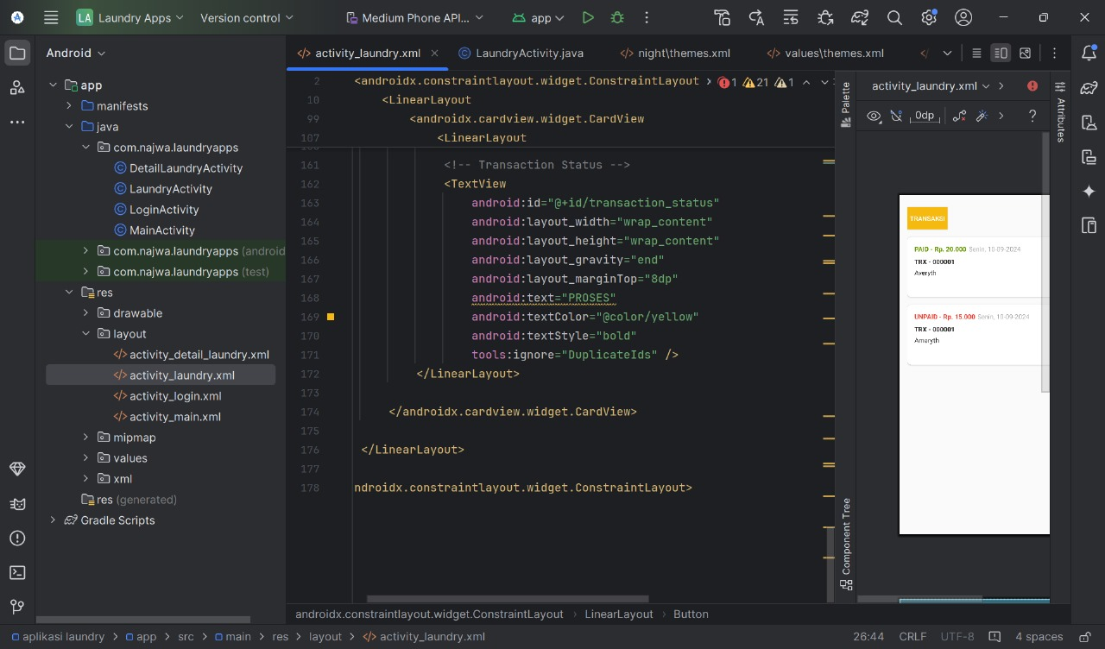

**Tampilan:**

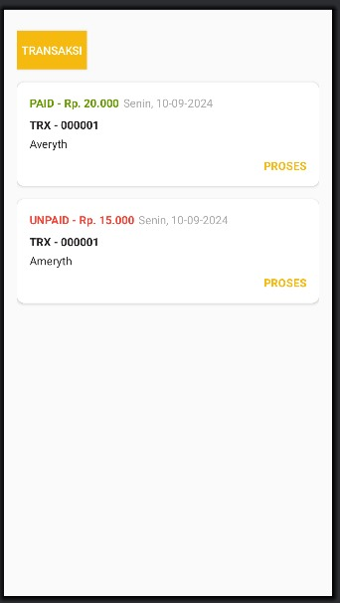

1. **DetailLaundryActivity**

digunakan untuk memperlihatkan secara detail Riwayat transaksi secara keseluruhan pada aplikasi

**Java:**

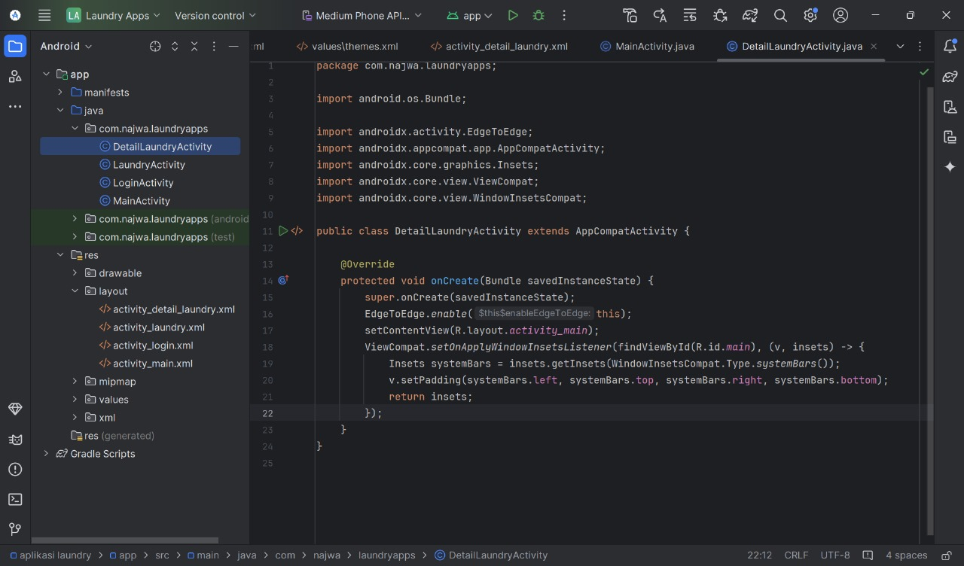

**XML:**

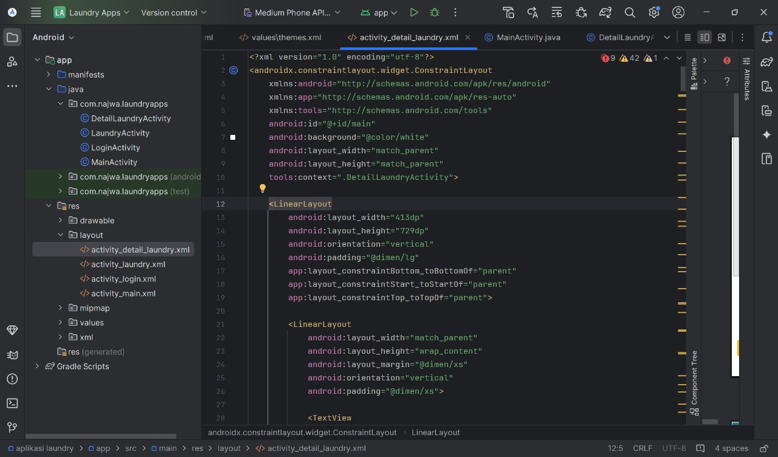

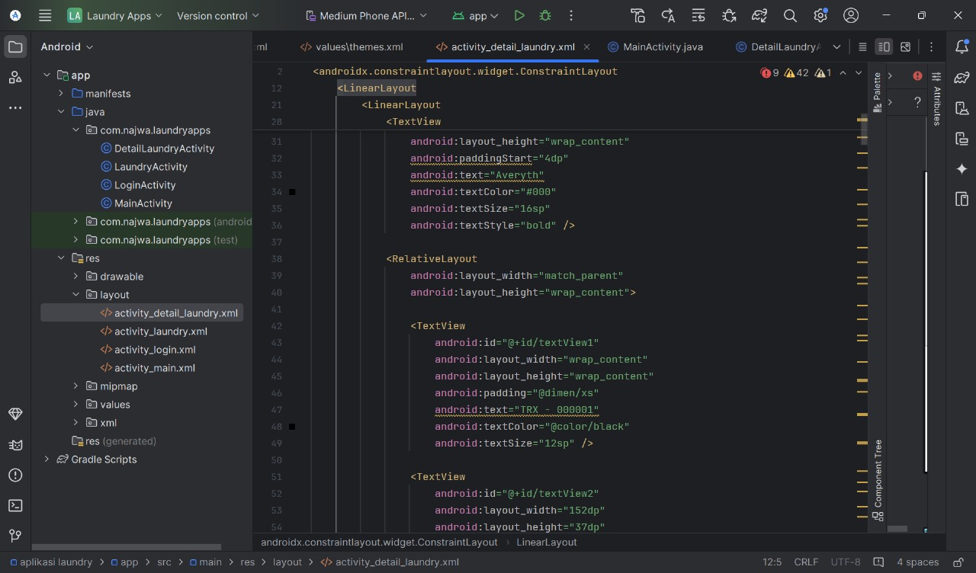

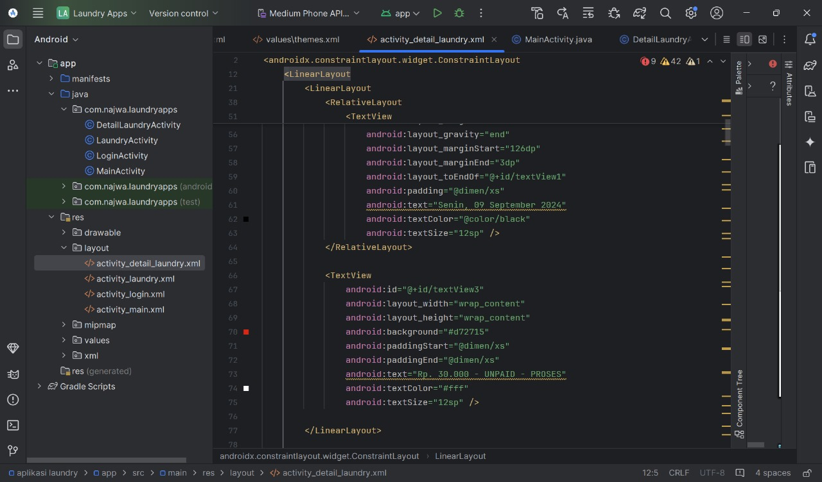

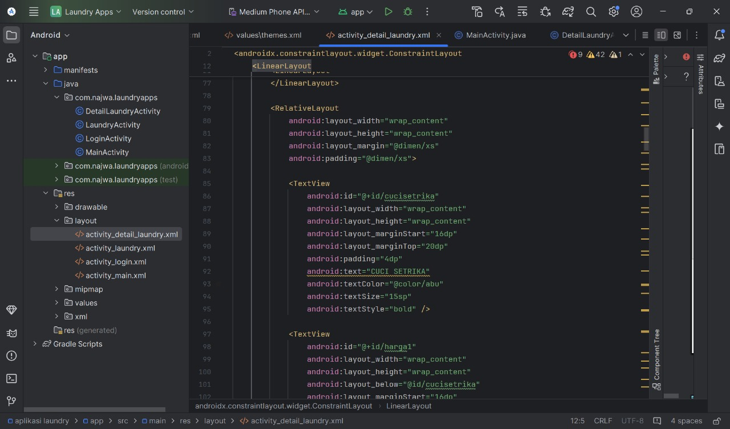

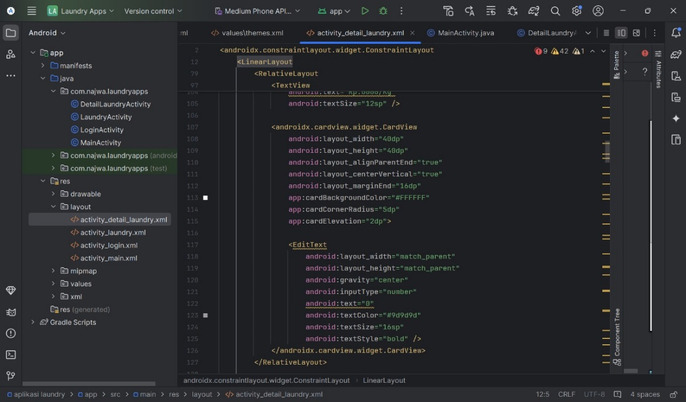

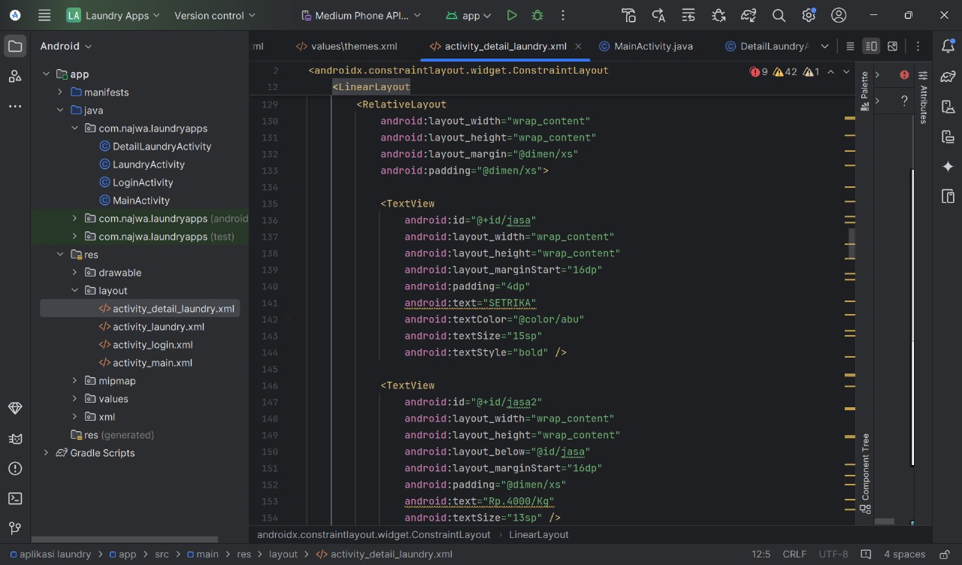

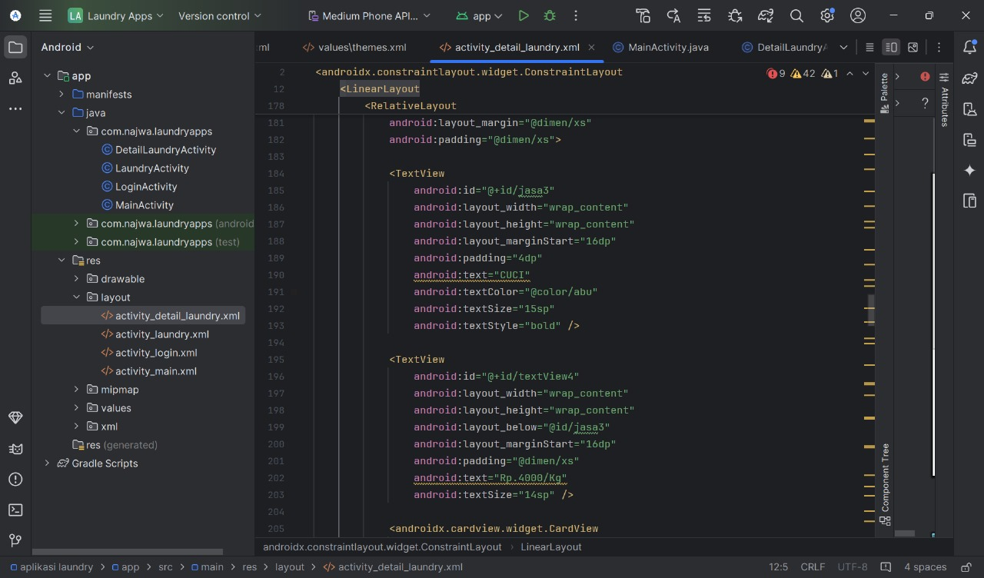



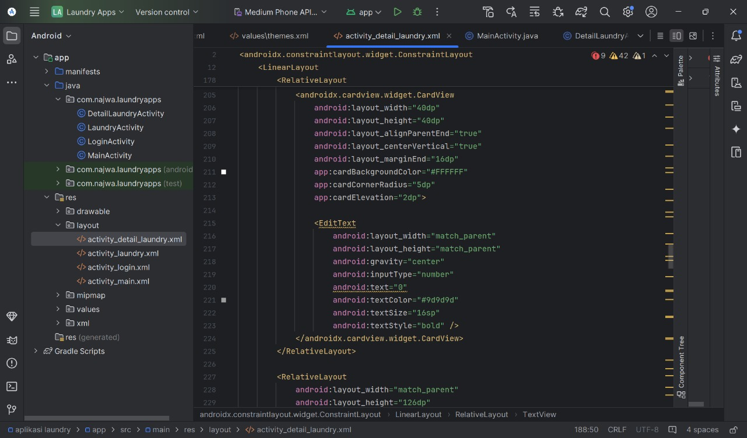

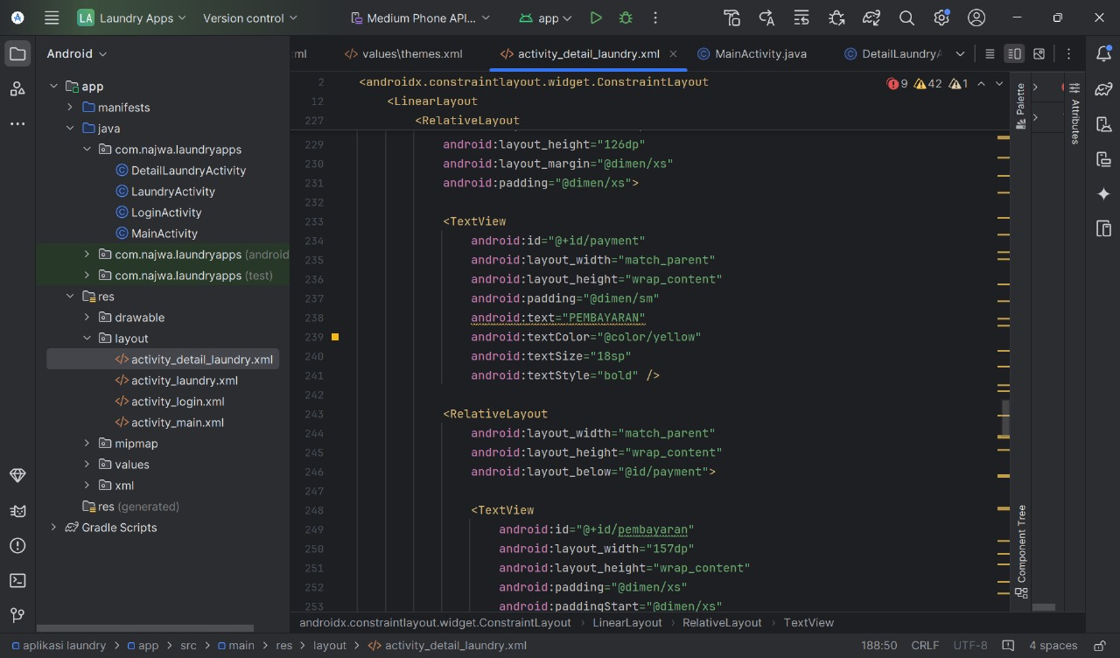

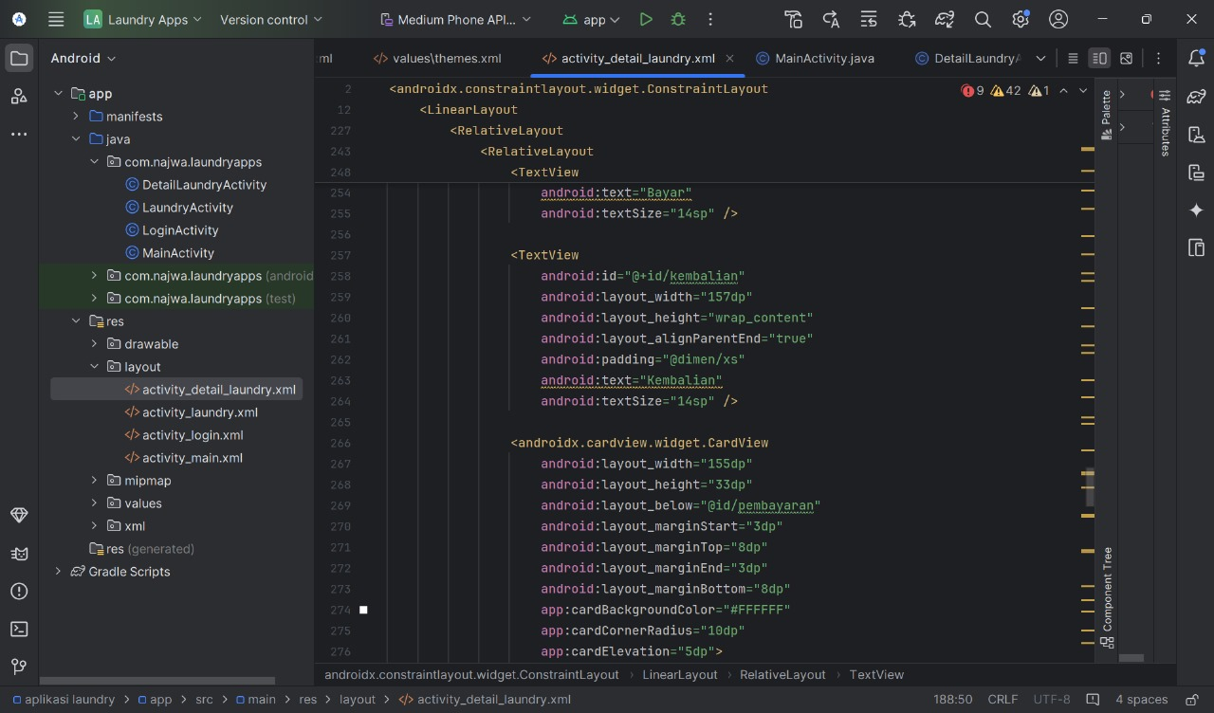

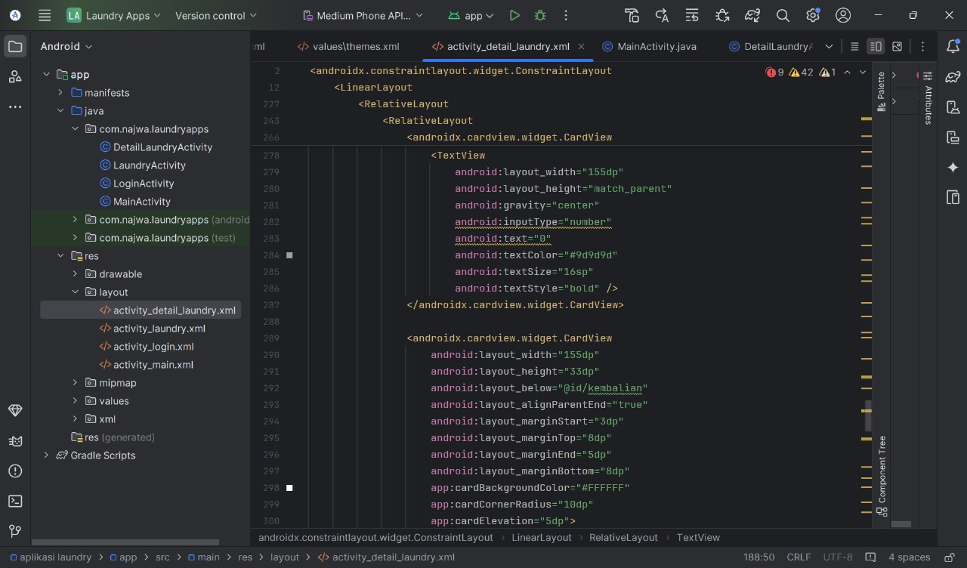

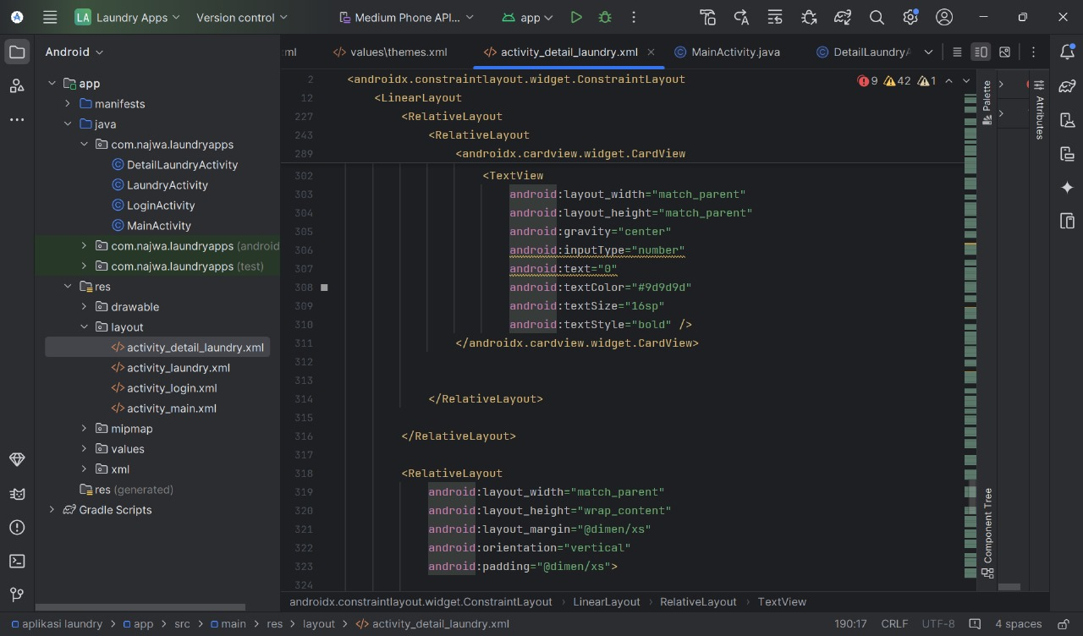

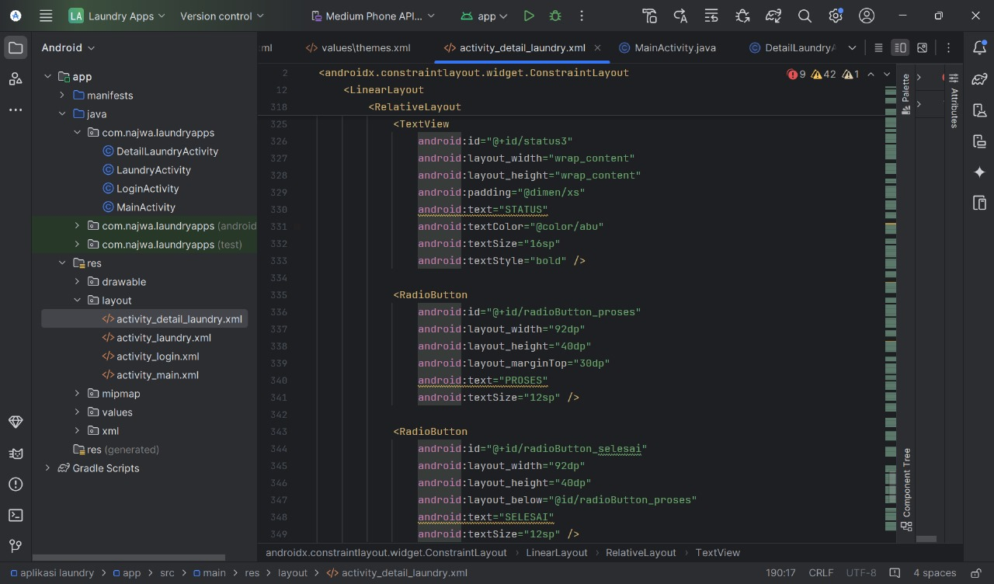

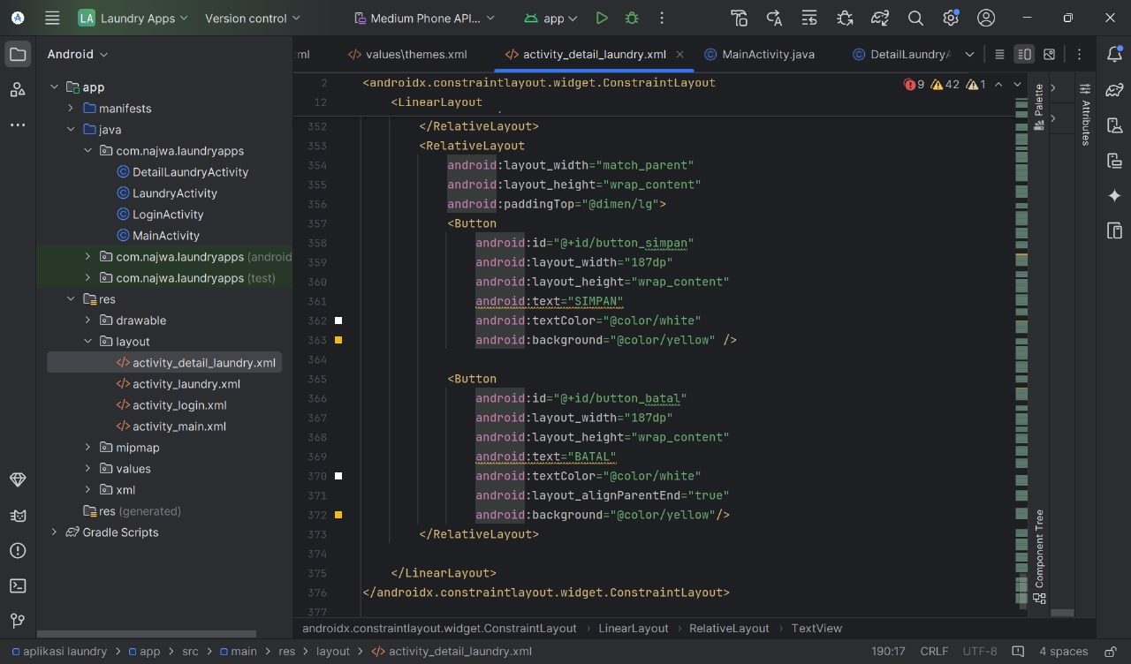

**Tampilan:**

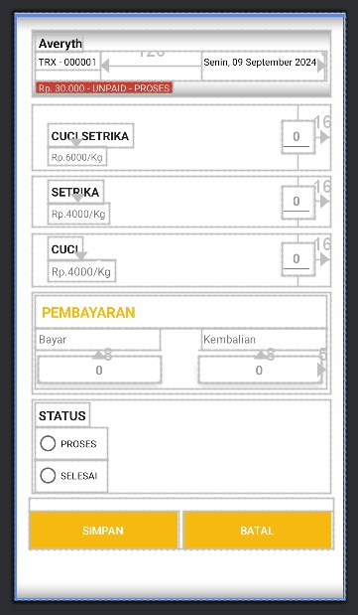

1. **AddLaundryActivity**

Activity ini ditujukan untuk menambahkan transaksi yang akan dilakukakn oleh petugas. **Java:**

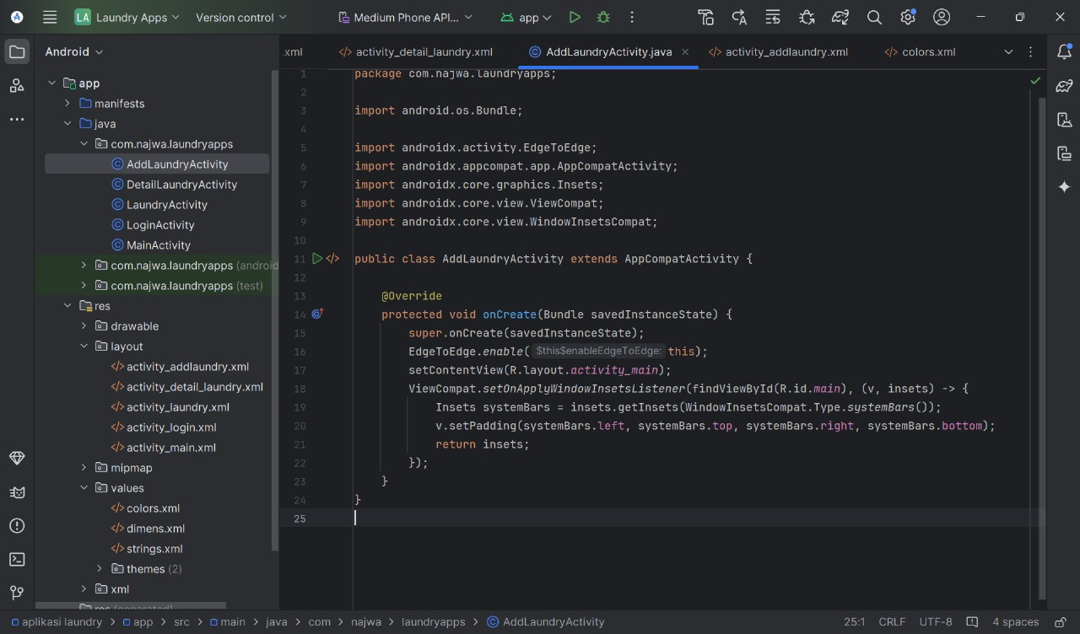

**XML:**

<?xml version="1.0" encoding="utf-8"?>

<androidx.constraintlayout.widget.ConstraintLayout xmlns:android="http://schemas.android.com/apk/res/android"

xmlns:app="http://schemas.android.com/apk/res-auto"

xmlns:tools="http://schemas.android.com/tools"

android:id="@+id/main"

android:background="@color/white"

android:layout_width="match_parent"

android:layout_height="match_parent"

tools:context=".AddLaundryActivity">

<LinearLayout

android:id="@+id/linearLayout"

android:layout_width="match_parent"

android:layout_height="wrap_content"

android:layout_margin="@dimen/sm"

android:orientation="vertical"

android:padding="@dimen/lg"

tools:layout_editor_absoluteX="10dp"

tools:layout_editor_absoluteY="14dp"

tools:ignore="MissingConstraints">

<TextView

android:id="@+id/textView1"

android:layout_width="wrap_content"

android:layout_height="wrap_content"

android:drawableStart="@mipmap/ic_username"

android:drawablePadding="@dimen/xs"

android:padding="@dimen/lg"

android:text="Pelanggan" />

<RelativeLayout

android:layout_width="wrap_content"

android:layout_height="wrap_content"

android:layout_margin="@dimen/lg"

android:padding="@dimen/lg"

tools:layout_editor_absoluteX="0dp"

tools:layout_editor_absoluteY="86dp"

android:background="@color/softyelow">

<TextView

android:id="@+id/textView2"

android:layout_width="wrap_content"

android:layout_height="wrap_content"

android:layout_alignParentStart="true"

android:layout_marginStart="16dp"

android:layout_marginTop="@dimen/xs"

android:padding="4dp"

android:text="CUCI SETRIKA"

android:textColor="@color/abu"

android:textSize="14sp"

android:textStyle="bold" />

<TextView

android:id="@+id/harga1"

android:layout_width="wrap_content"

android:layout_height="wrap_content"

android:layout_below="@id/textView2"

android:layout_alignParentStart="true"

android:layout_marginStart="16dp"

android:padding="@dimen/xs"

android:text="Rp.6000/Kg"

android:textSize="12sp" />

<androidx.cardview.widget.CardView

android:layout_width="40dp"

android:layout_height="40dp"

android:layout_alignParentEnd="true"

android:layout_centerVertical="true"

android:layout_marginEnd="16dp"

app:cardBackgroundColor="@color/white"

app:cardCornerRadius="5dp"

app:cardElevation="2dp">

<EditText

android:layout_width="match_parent"

android:layout_height="match_parent"

android:gravity="center"

android:inputType="number"

android:text="0"

android:textColor="#9d9d9d"

android:textSize="16sp"

android:textStyle="bold" />

</androidx.cardview.widget.CardView>

</RelativeLayout>

<RelativeLayout

android:layout_width="wrap_content"

android:layout_height="wrap_content"

android:layout_margin="@dimen/lg"

android:padding="@dimen/lg"

tools:layout_editor_absoluteX="0dp"

tools:layout_editor_absoluteY="185dp"

android:background="@color/softyelow">

<TextView

android:id="@+id/textView3"

android:layout_width="wrap_content"

android:layout_height="wrap_content"

android:layout_alignParentStart="true"

android:layout_marginStart="16dp"

android:padding="4dp"

android:text="SETRIKA"

android:textColor="@color/abu"

android:textSize="14sp"

android:textStyle="bold" />

<TextView

android:id="@+id/harga2"

android:layout_width="wrap_content"

android:layout_height="wrap_content"

android:layout_below="@id/textView3"

android:layout_alignParentStart="true"

android:layout_marginStart="16dp"

android:padding="@dimen/xs"

android:text="Rp.4000/Kg"

android:textSize="13sp" />

<androidx.cardview.widget.CardView

android:layout_width="40dp"

android:layout_height="40dp"

android:layout_alignParentEnd="true"

android:layout_centerVertical="true"

android:layout_marginEnd="16dp"

app:cardBackgroundColor="#FFFFFF"

app:cardCornerRadius="5dp"

app:cardElevation="2dp">

<EditText

android:layout_width="match_parent"

android:layout_height="match_parent"

android:gravity="center"

android:inputType="number"

android:text="0"

android:textColor="#9d9d9d"

android:textSize="16sp"

android:textStyle="bold" />

</androidx.cardview.widget.CardView>

</RelativeLayout>

<RelativeLayout

android:layout_width="wrap_content"

android:layout_height="wrap_content"

android:layout_margin="@dimen/lg"

android:padding="@dimen/lg"

tools:layout_editor_absoluteX="0dp"

tools:layout_editor_absoluteY="281dp"

android:background="@color/softyelow">

<TextView

android:id="@+id/textView4"

android:layout_width="wrap_content"

android:layout_height="wrap_content"

android:layout_alignParentStart="true"

android:layout_marginStart="16dp"

android:padding="4dp"

android:text="CUCI"

android:textColor="@color/abu"

android:textSize="14sp"

android:textStyle="bold" />

<TextView

android:id="@+id/textView5"

android:layout_width="wrap_content"

android:layout_height="wrap_content"

android:layout_below="@id/textView4"

android:layout_alignParentStart="true"

android:layout_marginStart="16dp"

android:padding="@dimen/xs"

android:text="Rp.4000/Kg"

android:textSize="14sp" />

<androidx.cardview.widget.CardView

android:layout_width="40dp"

android:layout_height="40dp"

android:layout_alignParentEnd="true"

android:layout_centerVertical="true"

android:layout_marginEnd="16dp"

app:cardBackgroundColor="#FFFFFF"

app:cardCornerRadius="5dp"

app:cardElevation="2dp">

<EditText

android:layout_width="match_parent"

android:layout_height="match_parent"

android:gravity="center"

android:inputType="number"

android:text="0"

android:textColor="#9d9d9d"

android:textSize="16sp"

android:textStyle="bold" />

</androidx.cardview.widget.CardView>

</RelativeLayout>

<RelativeLayout

android:layout_width="match_parent"

android:layout_height="75dp"

android:layout_margin="@dimen/xs"

android:padding="@dimen/xs">

<TextView

android:id="@+id/total"

android:layout_width="wrap_content"

android:layout_height="wrap_content"

android:layout_alignParentEnd="true"

android:layout_marginEnd="2dp"

android:gravity="end"

android:text="Total"

android:textColor="@color/black" />

<TextView

android:id="@+id/harga"

android:layout_width="wrap_content"

android:layout_height="wrap_content"

android:text="Rp. 30.000"

android:layout_alignParentEnd="true"

android:layout_below="@id/total"

android:layout_alignEnd="@id/total"

android:gravity="end"

android:paddingTop="25dp"/>

</RelativeLayout>

<RelativeLayout

android:layout_width="match_parent"

android:layout_height="wrap_content"

android:padding="@dimen/lg"

android:paddingTop="@dimen/lg"

android:layout_marginTop="20dp"

tools:layout_editor_absoluteX="0dp"

tools:layout_editor_absoluteY="457dp">

<Button

android:id="@+id/button"

android:layout_width="149dp"

android:layout_height="wrap_content"

android:layout_alignParentStart="true"

android:background="@color/yellow"

android:text="SIMPAN"

android:textColor="@color/white"/>

<Button

android:id="@+id/button3"

android:layout_width="149dp"

android:layout_height="wrap_content"

android:layout_alignParentEnd="true"

android:background="@color/yellow"

android:text="BATAL"

android:textColor="@color/white"/>

</RelativeLayout>

</LinearLayout>

</androidx.constraintlayout.widget.ConstraintLayout>

**Tampilan:**

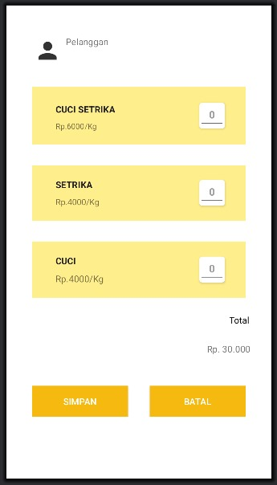

1. **LayananActivity**

Activity ini akan menampilkan layanan apa saja yang tersedia dan harga per Kg nya dan juga terdapat juga fitur tambah layanan.

**Java:**

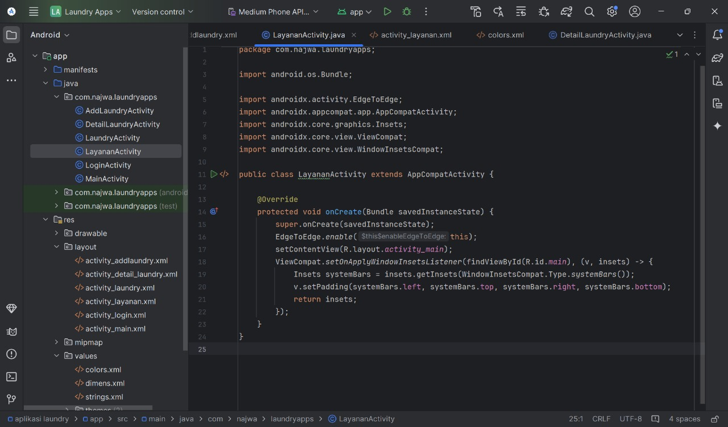

**XML:**

<?xml version="1.0" encoding="utf-8"?>

<androidx.constraintlayout.widget.ConstraintLayout xmlns:android="http://schemas.android.com/apk/res/android"

xmlns:app="http://schemas.android.com/apk/res-auto"

xmlns:tools="http://schemas.android.com/tools"

android:id="@+id/main"

android:background="@color/white"

android:layout_width="match_parent"

android:layout_height="match_parent"

tools:context=".LoginActivity">

<LinearLayout

android:layout_width="match_parent"

android:layout_height="wrap_content"

android:orientation="vertical"

android:padding="@dimen/lg"

app:layout_constraintTop_toTopOf="parent"

app:layout_constraintVertical_bias="0.497">

<TextView

android:id="@+id/textView1"

android:layout_width="wrap_content"

android:layout_height="wrap_content"

android:background="@color/yellow"

android:padding="@dimen/sm"

android:text="TAMBAH LAYANAN"

android:textColor="@color/white"

android:textStyle="bold"

android:textSize="16sp"/>

<RelativeLayout

android:layout_width="match_parent"

android:layout_height="wrap_content"

android:layout_margin="@dimen/sm"

android:padding="@dimen/sm"

android:paddingTop="@dimen/lg"

tools:layout_editor_absoluteX="0dp"

tools:layout_editor_absoluteY="86dp">

<TextView

android:id="@+id/textView2"

android:layout_width="wrap_content"

android:layout_height="wrap_content"

android:layout_alignParentStart="true"

android:layout_marginStart="16dp"

android:layout_marginTop="@dimen/xs"

android:padding="4dp"

android:text="CUCI SETRIKA"

android:textColor="@color/abu"

android:textSize="14sp"

android:textStyle="bold" />

<TextView

android:id="@+id/textview7"

android:layout_width="wrap_content"

android:layout_height="wrap_content"

android:layout_below="@id/textView2"

android:layout_alignParentStart="true"

android:layout_marginStart="16dp"

android:padding="@dimen/xs"

android:text="Rp.6000/Kg"

android:textSize="12sp" />

</RelativeLayout>

<RelativeLayout

android:layout_width="match_parent"

android:layout_height="wrap_content"

android:layout_margin="@dimen/sm"

android:padding="@dimen/sm"

tools:layout_editor_absoluteX="0dp"

tools:layout_editor_absoluteY="185dp">

<TextView

android:id="@+id/textView3"

android:layout_width="wrap_content"

android:layout_height="wrap_content"

android:layout_alignParentStart="true"

android:layout_marginStart="16dp"

android:padding="4dp"

android:text="SETRIKA"

android:textColor="@color/abu"

android:textSize="14sp"

android:textStyle="bold" />

<TextView

android:id="@+id/textView4"

android:layout_width="wrap_content"

android:layout_height="wrap_content"

android:layout_below="@id/textView3"

android:layout_alignParentStart="true"

android:layout_marginStart="16dp"

android:padding="@dimen/xs"

android:text="Rp.4000/Kg"

android:textSize="13sp" />

</RelativeLayout>

<RelativeLayout

android:layout_width="match_parent"

android:layout_height="wrap_content"

android:layout_margin="@dimen/sm"

android:padding="@dimen/sm"

tools:layout_editor_absoluteX="0dp"

tools:layout_editor_absoluteY="281dp">

<TextView

android:id="@+id/textView6"

android:layout_width="wrap_content"

android:layout_height="wrap_content"

android:layout_alignParentStart="true"

android:layout_marginStart="16dp"

android:padding="4dp"

android:text="CUCI"

android:textColor="@color/abu"

android:textSize="16sp"

android:textStyle="bold" />

<TextView

android:id="@+id/harga3"

android:layout_width="wrap_content"

android:layout_height="wrap_content"

android:layout_below="@id/textView6"

android:layout_alignParentStart="true"

android:layout_marginStart="16dp"

android:padding="@dimen/xs"

android:text="Rp.4000/Kg"

android:textSize="14sp" />

</RelativeLayout>

</LinearLayout>

</androidx.constraintlayout.widget.ConstraintLayout>

**Tampilan:**

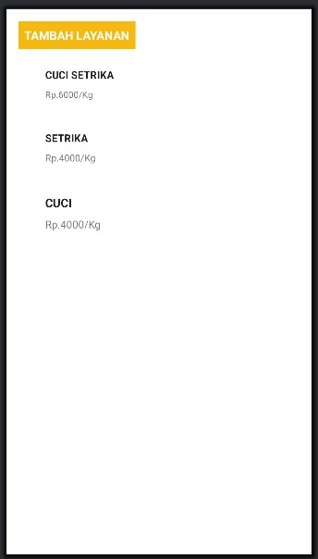

1. **PelangganActivity**

Activity digunakan untuk menampilkan menambahkan, mengubah dan menghapus data pelanggan oleh petugas. **Java:**

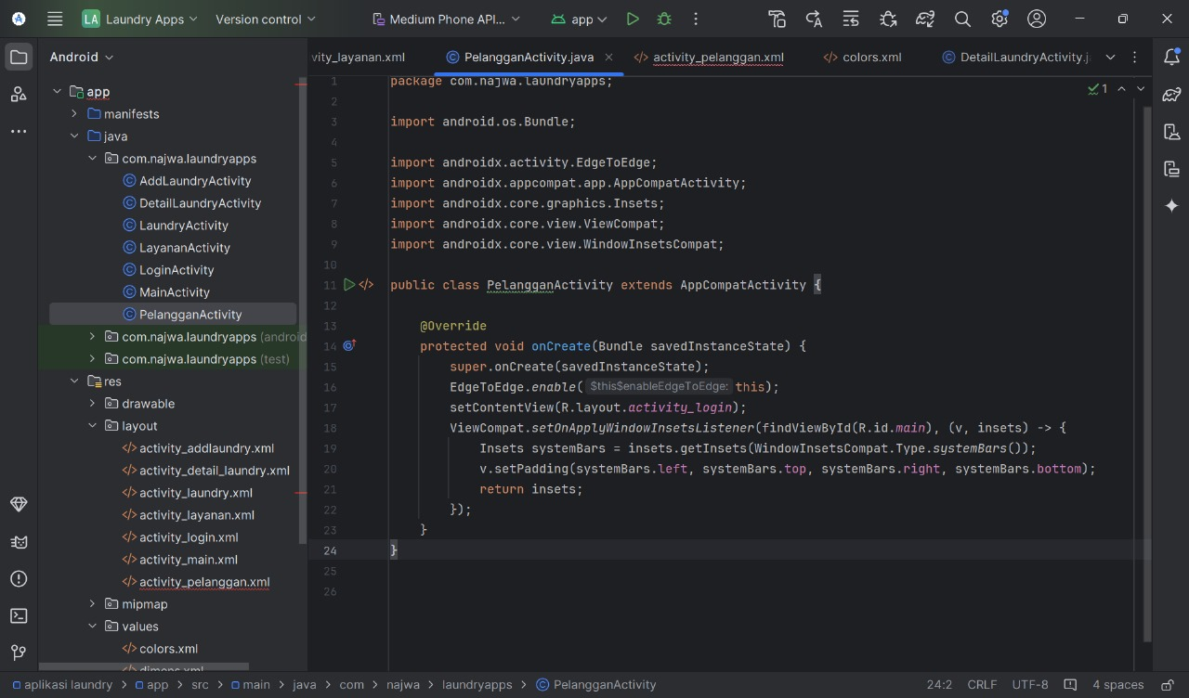

**XML:**

<?xml version="1.0" encoding="utf-8"?>

<androidx.constraintlayout.widget.ConstraintLayout xmlns:android="http://schemas.android.com/apk/res/android"

xmlns:app="http://schemas.android.com/apk/res-auto"

xmlns:tools="http://schemas.android.com/tools"

android:id="@+id/main"

android:background="@color/white"

android:layout_width="match_parent"

android:layout_height="match_parent"

tools:context=".PelangganActivity">

<LinearLayout

android:layout_width="match_parent"

android:layout_height="wrap_content"

android:orientation="vertical"

android:padding="@dimen/lg"

app:layout_constraintTop_toTopOf="parent"

app:layout_constraintVertical_bias="0.497">

<TextView

android:id="@+id/textView"

android:layout_width="wrap_content"

android:layout_height="wrap_content"

android:background="@color/yellow"

android:padding="@dimen/sm"

android:text="TAMBAH PELANGGAN"

android:textColor="@color/white"

android:textStyle="bold"

android:textSize="@dimen/lg"/>

<RelativeLayout

android:layout_width="match_parent"

android:layout_height="wrap_content"

android:layout_margin="@dimen/sm"

android:padding="@dimen/sm"

android:paddingTop="@dimen/lg"

tools:layout_editor_absoluteX="0dp"

tools:layout_editor_absoluteY="86dp"

android:background="@color/softyelow">

<TextView

android:id="@+id/textView1"

android:layout_width="wrap_content"

android:layout_height="wrap_content"

android:layout_alignParentStart="true"

android:layout_marginStart="16dp"

android:layout_marginTop="@dimen/xs"

android:padding="4dp"

android:text="Averyth"

android:textColor="@color/abu"

android:textSize="18sp"

android:textStyle="bold" />

<TextView

android:id="@+id/textNomor1"

android:layout_width="wrap_content"

android:layout_height="wrap_content"

android:layout_below="@id/textView1"

android:layout_alignParentStart="true"

android:layout_marginStart="16dp"

android:padding="@dimen/xs"

android:text="0821154678"

android:textSize="12sp" />

</RelativeLayout>

<RelativeLayout

android:layout_width="match_parent"

android:layout_height="wrap_content"

android:layout_margin="@dimen/sm"

android:padding="@dimen/sm"

tools:layout_editor_absoluteX="0dp"

tools:layout_editor_absoluteY="185dp"

android:background="@color/softyelow">

<TextView

android:id="@+id/textView2"

android:layout_width="wrap_content"

android:layout_height="wrap_content"

android:layout_alignParentStart="true"

android:layout_marginStart="16dp"

android:padding="4dp"

android:text="Louvessya"

android:textColor="@color/abu"

android:textSize="18sp"

android:textStyle="bold" />

<TextView

android:id="@+id/textNomor2"

android:layout_width="wrap_content"

android:layout_height="wrap_content"

android:layout_below="@id/textView2"

android:layout_alignParentStart="true"

android:layout_marginStart="16dp"

android:padding="@dimen/xs"

android:text="0875642973"

android:textSize="13sp" />

</RelativeLayout>

<RelativeLayout

android:layout_width="match_parent"

android:layout_height="wrap_content"

android:layout_margin="@dimen/sm"

android:padding="@dimen/sm"

tools:layout_editor_absoluteX="0dp"

tools:layout_editor_absoluteY="281dp"

android:background="@color/softyelow">

<TextView

android:id="@+id/textView3"

android:layout_width="wrap_content"

android:layout_height="wrap_content"

android:layout_alignParentStart="true"

android:layout_marginStart="16dp"

android:padding="4dp"

android:text="Jecafya"

android:textColor="@color/abu"

android:textSize="18sp"

android:textStyle="bold" />

<TextView

android:id="@+id/textNomor3"

android:layout_width="wrap_content"

android:layout_height="wrap_content"

android:layout_below="@id/textView3"

android:layout_alignParentStart="true"

android:layout_marginStart="16dp"

android:padding="@dimen/xs"

android:text="0854787834"

android:textSize="14sp" />

</RelativeLayout>

</LinearLayout>

</androidx.constraintlayout.widget.ConstraintLayout>

**Tampilan:**

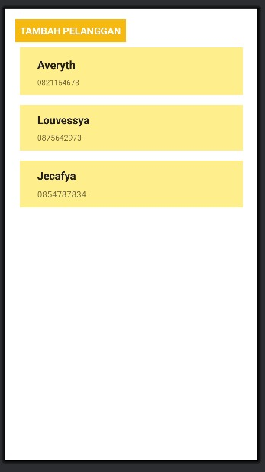

1. **PromoActivity**

Activity ini digunakan untuk menampilkan, menambahkan, mengubah dan menghapus data promo. **Java:**

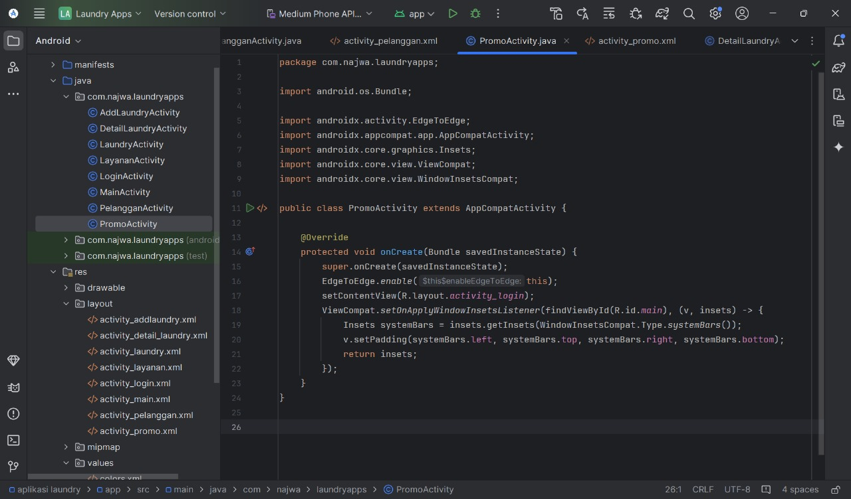

**XML:**

<?xml version="1.0" encoding="utf-8"?>

<androidx.constraintlayout.widget.ConstraintLayout xmlns:android="http://schemas.android.com/apk/res/android"

xmlns:app="http://schemas.android.com/apk/res-auto"

xmlns:tools="http://schemas.android.com/tools"

android:id="@+id/main"

android:layout_width="match_parent"

android:layout_height="match_parent"

tools:context=".PromoActivity">

<LinearLayout

android:layout_width="match_parent"

android:layout_height="match_parent"

android:background="#FFFFFF"

android:orientation="vertical"

android:padding="16dp">

<!--button-->

<Button

android:id="@+id/button2"

android:layout_width="wrap_content"

android:layout_height="wrap_content"

android:text="Promo"

android:background="@color/yellow"

android:textColor="@color/white"

android:textSize="17dp"/>

<!-- fulan -->

<LinearLayout

android:layout_width="match_parent"

android:layout_height="wrap_content"

android:layout_marginTop="16dp"

android:background="@color/softyelow"

android:elevation="2dp"

android:orientation="vertical"

android:padding="16dp">

<TextView

android:layout_width="wrap_content"

android:layout_height="wrap_content"

android:text="HARIANMURAH"

android:textColor="@color/abu"

android:textSize="25dp"

android:textStyle="bold" />

<TextView

android:layout_width="302dp"

android:layout_height="43dp"

android:text="Promo cuci 10 kg gratis cuci 1 Kg berlaku untuk kelipatannya"

android:textSize="16sp" />

<LinearLayout

android:layout_width="100dp"

android:layout_height="35dp"

android:orientation="horizontal">

<FrameLayout

android:layout_width="93dp"

android:layout_height="29dp"

android:layout_gravity="center"

android:background="@color/yellow">

<TextView

android:layout_width="wrap_content"

android:layout_height="wrap_content"

android:layout_gravity="center"

android:text="Active"

android:textStyle="bold"

android:textColor="#FFFFFF"

android:textSize="20dp">

</TextView>

</FrameLayout>

</LinearLayout>

</LinearLayout>

<!-- fulan -->

<LinearLayout

android:layout_width="match_parent"

android:layout_height="wrap_content"

android:layout_marginTop="16dp"

android:background="@color/softyelow"

android:elevation="2dp"

android:orientation="vertical"

android:padding="16dp">

<TextView

android:layout_width="wrap_content"

android:layout_height="wrap_content"

android:text="MINGGUANMURAH"

android:textColor="@color/abu"

android:textSize="25dp"

android:textStyle="bold" />

<TextView

android:layout_width="302dp"

android:layout_height="43dp"

android:text="Promo cuci 10 kg gratis cuci 1 Kg berlaku untuk kelipatannya"

android:textSize="16sp" />

<LinearLayout

android:layout_width="100dp"

android:layout_height="35dp"

android:orientation="horizontal">

<FrameLayout

android:layout_width="93dp"

android:layout_height="29dp"

android:layout_gravity="center"

android:background="@color/yellow">

<TextView

android:layout_width="wrap_content"

android:layout_height="wrap_content"

android:layout_gravity="center"

android:text="Active"

android:textStyle="bold"

android:textColor="#FFFFFF"

android:textSize="20dp">

</TextView>

</FrameLayout>

</LinearLayout>

</LinearLayout>

</LinearLayout>

</androidx.constraintlayout.widget.ConstraintLayout>

**Tampilan:**

